

SOFTWARE DESIGN DESCRIPTION
For
AI LEGAL ASSISTANT
Version 1.0
By

IZMA WARA KHAN (2022F-BSE-184)
DILAFROZE (2022F-BSE-193)
MUHAMMAD BILAL (2022F-BSE-190)

Supervisor
Engr. Nida Khalil/Engr. Priha Bhatti

Bachelor of Science in Software Engineering (2025-2026)

Table of Contents

Introduction
  - Purpose
  - Scope
  - Project Background
  - Motivation
  - Project Objective

Design Methodology and Software Process Model
  - Design Methodology
  - Design Pattern (Creational, Structural, Behavioral) (Also give reasoning)
  - Software Process Models (Classical, Modern or Agile)

System Overview
  - Architectural Design (Client Server, Distributed, Cloud, ….)
  - Process Flow (Functional Requirement)

Project Architecture
  - Web/ Android module
    - Functions (UI Designing – Sigma, Canva) (UX based methodology)
    - Architecture (Box and Line Diagram)
  - Database module (Justification), Type, DDL (Data Definition Table)
  - Administration module
  - Data Dictionary

. System Analysis & Design Overview
  - Class Diagrams
  - System Sequence Diagrams
  - State Transition Diagram
  - Schematic diagram (Hardware projects only)
  - Timing diagram (Hardware projects only)

- Introduction:

1.1 Purpose:
This SDD presents a detailed design overview of the Legal AI Platform. It describes, among other aspects, the system architecture, modules, components, data design, and mechanisms of interaction. This document will serve as a reference for developers, supervisors, and evaluators in understanding how the system is structured and implemented.

1.2 Scope:
The Legal AI Platform is an online platform which brings together lawyers and their clients using artificial intelligence and communication tools. The platform offers legal advice by artificial intelligence, finding and consulting lawyers, live chatting, and administrative monitoring.
The platform is meant to increase access to lawyers in an efficient, safe, and convenient way.

1.3 Project Background:
This is especially true concerning legal services, which tend to be time-consuming, cost-prohibitive, and complicated for common people. This is besides people not having any legal literacy and finding it difficult to identify the right lawyer. With advancements in artificial intelligence and web development, it has become feasible to automatically provide initial legal advice and connect people with a lawyer.

1.4 Motivation:
The motivation for this project is the need for an upgrade in the legal consultation process, making it less reliant on visits and allowing for immediate legal help. The purpose of this system is time efficiency, transparency, and maintaining confidentiality during legal consultations that are accessible to the public.

1.5 Project Objectives:
- For AI legal advice through machine learning
- To match lawyers with clients based on specialization
- Facilitate secure communication through end-to-end encryption
- To manage users and system activities through admin panel
- To maintain data privacy and system integrity

- Design Methodology and Software Process Model
2.1 Design Methodology:
The system follows a modular and object-oriented design methodology. Each module is designed independently to ensure scalability, maintainability, and reusability. User-centered design principles are applied to ensure ease of use.

2.2 Design Patterns
- Creational Pattern: Factory pattern is used for user creation (Client, Lawyer, Admin)
- Structural Pattern: MVC (Model-View-Controller) is used to separate business logic from UI
- Behavioral Pattern: Observer pattern is used for real-time chat notifications
These patterns improve flexibility, scalability, and system organization.

2.3 Software Process Model:
The Agile software development model is adopted. Agile allows continuous feedback, incremental development, and flexibility in handling changing requirements throughout the development lifecycle.

- System Overview:
3.1 Architectural Design:
The system follows a Client–Server Architecture with cloud-based deployment. The frontend communicates with backend services through secure APIs, while the database and AI modules operate on the server side.

  - Process Flow:
- User registers and logs into the system
- Client interacts with AI chatbot for legal guidance
- Client searches for lawyers by specialization
- Consultation request is sent to a lawyer
- Lawyer accepts or rejects the request
- Secure live chat is initiated upon acceptance
- Admin monitors system activities and logs

- Project Architecture
4.1 Web Module:
4.1.1 Functions:
The user interface is designed with a logical and intuitive flow to cater to three primary user roles: Client, Lawyer, and Admin.
- Role-Based Navigation: Upon accessing the application, users are prompted to select their respective roles, which then directs them through specialized authentication and onboarding paths.
- Client Experience: Designed for simplicity, the client dashboard provides quick access to the AI Chatbot, case consultation, and a limited view of relevant legal cases.
- Lawyer Experience: The lawyer interface is more data-intensive, allowing for full case access, advanced AI assistance, and detailed case analysis tools.
- Administrative Oversight: A dedicated Admin Panel is integrated to manage accounts, perform system maintenance, and ensure overall system control.
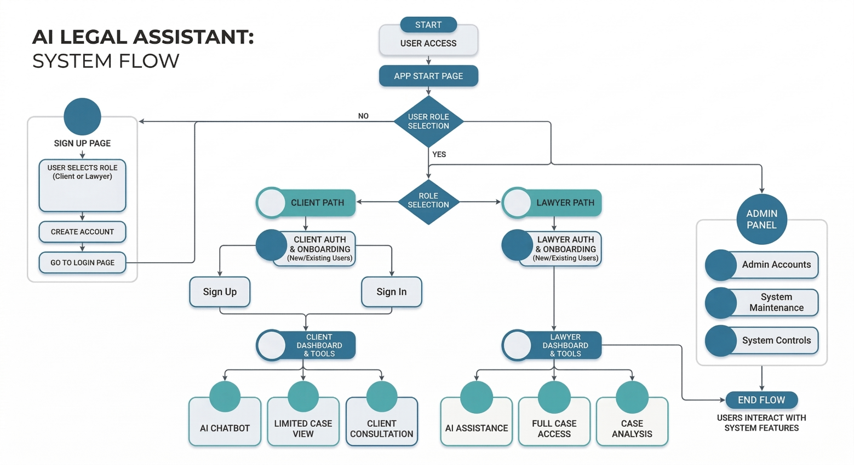
4.1.2 Architecture:
The architecture follows a modular and layered approach to ensure scalability and high performance.
- Modular Separation: The system is divided into distinct layers: The Frontend Layer for user interaction, the Backend Layer for processing, and the AI/Storage Layer for intelligence and data persistence.
- Data Flow: As illustrated in the Box and Line Diagram, user queries are routed through a secure FastAPI server which communicates with the Llama 3.3 model via the LangChain framework.
- Retrieval-Augmented Generation (RAG): The architecture integrates a Vector Store (FAISS) to fetch verified legal data from a database of Pakistani law categories, ensuring that the AI output is legally accurate.
- Integration: The module is tightly integrated with MongoDB Atlas for session management and Cloudinary for secure storage of lawyer credentials.
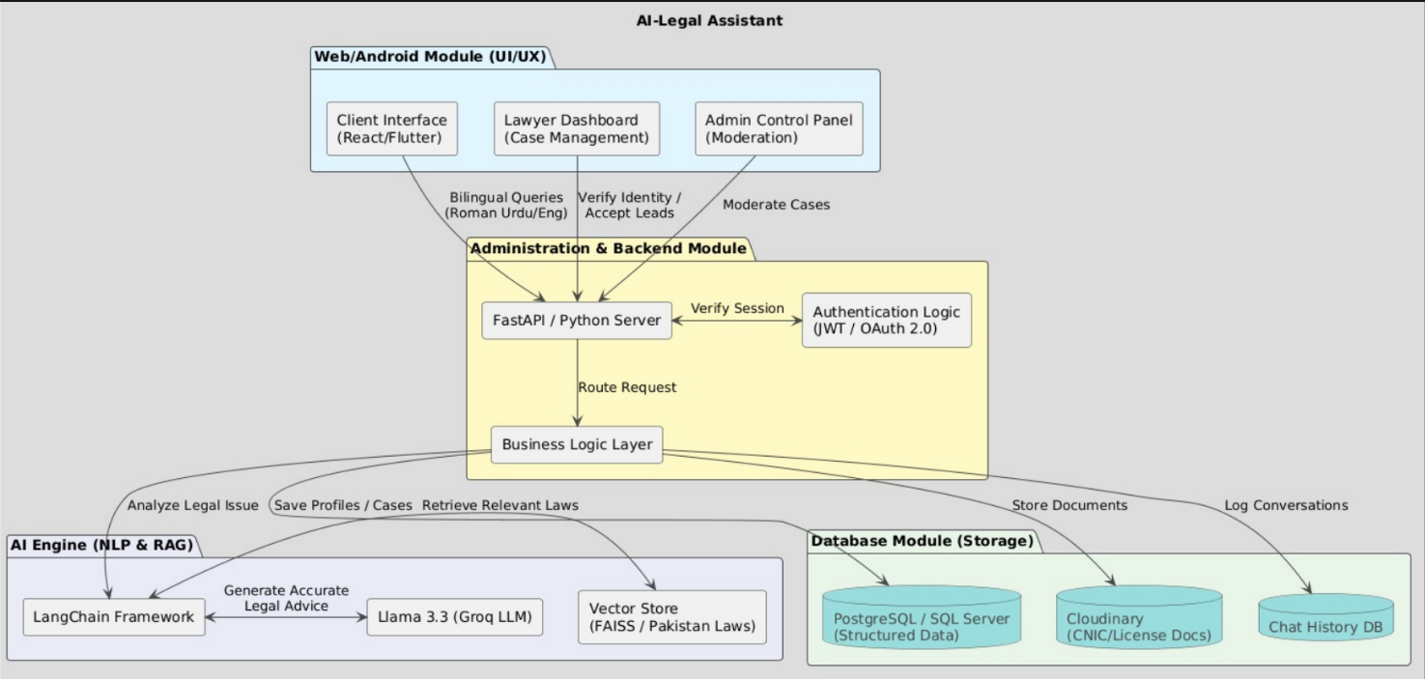
4.2 Database Module
Justification:
A relational database is used to ensure data consistency and integrity.
Database Type:
MySQL
Major Tables:
Users
Lawyers
Clients
Consultations
Messages
System Logs
4.3 Administration Module:
The admin module allows administrators to:
Manage users (Client, Lawyer)
Monitor chat and system logs
Handle reports and system issues
Ensure policy compliance
4.4 Data Dictionary:
UserID = Unique user identifier
Role = Client, Lawyer, Admin
Specialization = Lawyer expertise area
MessageID = Chat message identifier
Timestamp = Date and time of action

System Analysis & Design Overview

5.1 Class Diagrams:

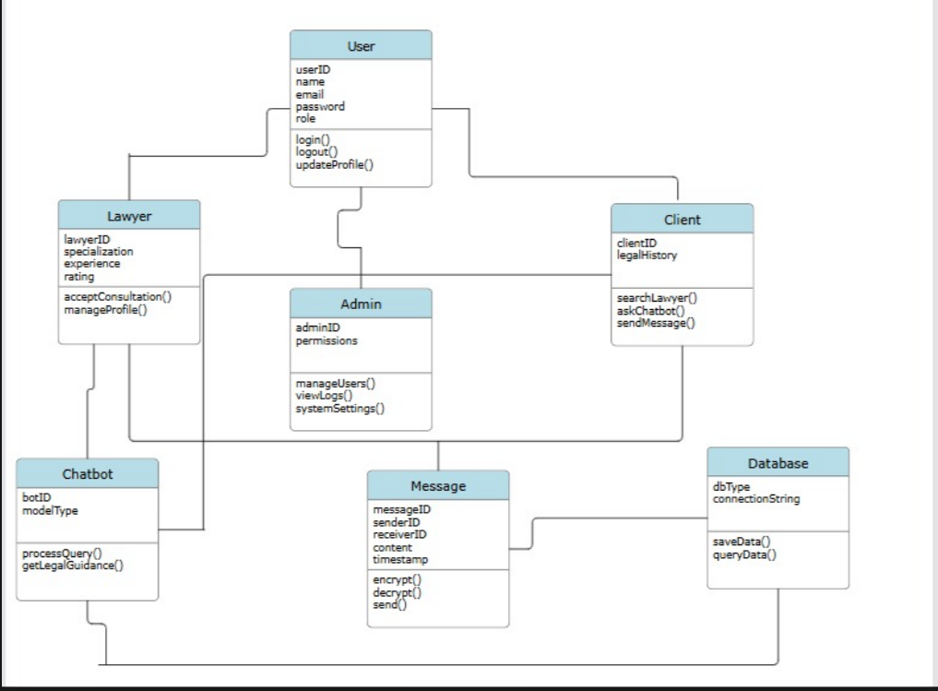

System Sequence Diagrams:

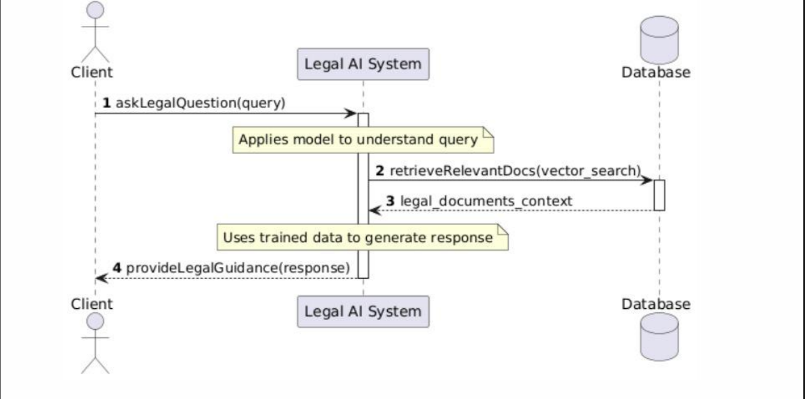

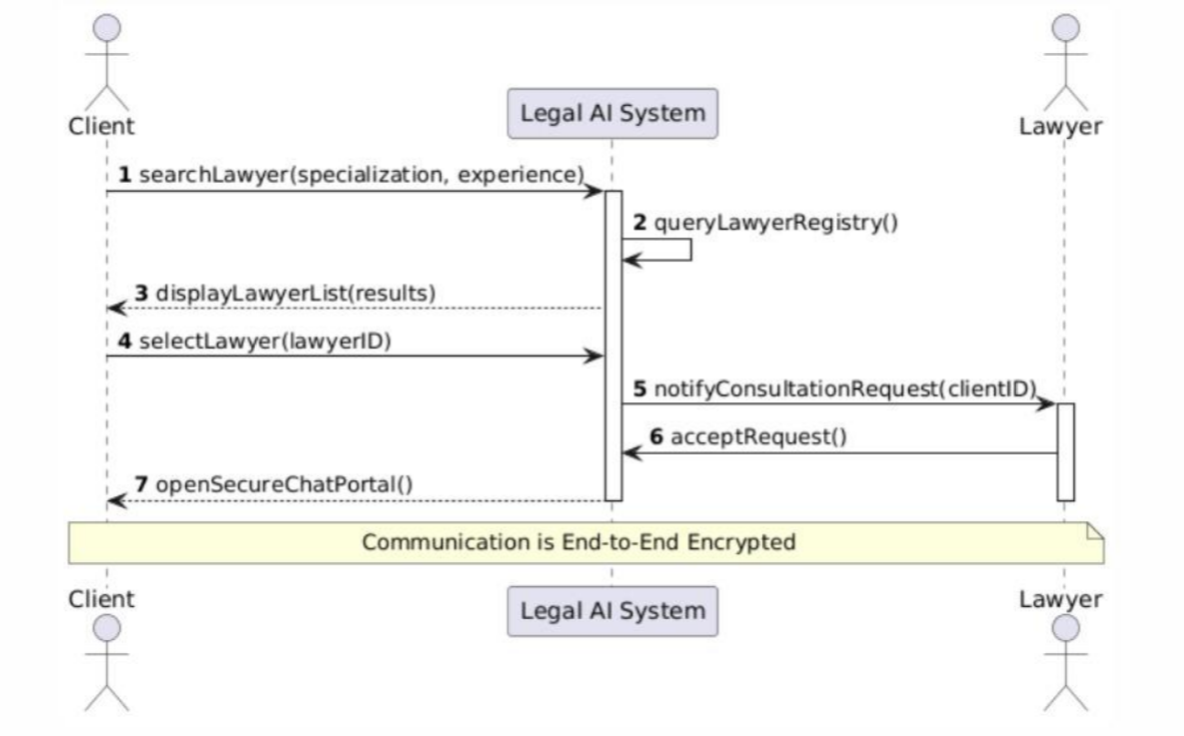

5.3 State Transition Diagram:

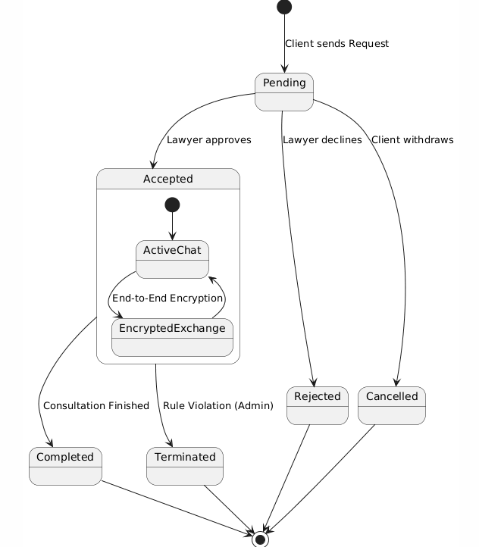

System State Diagram:
